# Project Report

# Food Sharing App

# CMPE 277 (Fall 2021)

**Student Name: Jaspreet Singh**

**Student ID: 014638390**

**Group Number: 4**

**GitHub Link:** [**https://github.com/Jaspreet-Singh-03/cmpe277-project**](https://github.com/Jaspreet-Singh-03/cmpe277-project)

**Nov. 2021**

# Table of Content

Executive Summary……………………….………………………….…………………………3

Chapter 1: Introduction……………………………………………..………………….….…4

Chapter 2: Background and Objectives…………………………………………………5

Chapter 3: Methodology………………………………………………………………..…....5

Chapter 4: Results, Finding and Analysis…………………………………………...…7

Chapter 5: Conclusion and Recommendation…………………………..………….9

References…………………………………………………………………………….…………..10

Source Code Snippets………………………………………………………………………...11

# Executive Summary

* The aim behind this project is to minimize the food wastage through sharing of food items. According to FDA , “In the United States alone, the food waste is estimated to be between 30-40 percent of food supply chain ( about $161 billions )” [1]
* The application will connect the users having surplus food items with other users who searching for free food items.
* The android app is designed to be simple to use, innovative and consumer-oriented.
* The user interface is kept simple and intuitive to use to capitalize maximum users and in all age range.

# Chapter 1: Introduction

My project is an android application and named as “Food Sharing App”. The purpose behind creating this app is to reduce the food wastage problem. The main aim of app is to match the users who want to donate food items for free to the other users who are in search of such items. For implementing this, the app will have the following main features

1. **Login:** To enhance the security for the application. User needs to either create a local account that is managed by Google‘s firebase API and then he can sign in to the app. The user also has an option to use their Google account to login to the app.
2. **Central Database to capture Food Orders:** to capture the details of food items such as the Name of the user who wants to donate the items, his contact information like phone number. The pickup available date and pickup location. If the food items in non-packed homemade cuisine then the user can enter the cuisine type also. All the captured details are saved in central database, currently using a local Docker instance of a Mongo dB database. Also, added validation of phone number, added support of date picker dialog, added location services to track the location and save it for later use.
3. **View My Orders:**  this button is used to view all the orders entered by the app user, so that he can keep a track of all the orders.
4. **Search and Match:** Used in-built map services/library. Used location services to show the users current location. Designed custom sorting algorithm to support the search and show the nearest pickup orders based on the provided search query which is displayed as pins/marker on the map view. Added another activity to show this result as a list using recycler view sorted on the nearest distance of pickup order.
5. **Material Design and Navigation View:** used the material design library and implemented the navigation drawer and navigation view to navigate through the different activities.
6. **Snack Bar and Error Handling:** added support for error handling and showing them as snack bar notifications. The Application supports handling of network connectivity errors, absent Play Services Framework error, and absent GPS sensor / Location disabled error. Apart from all this, the application also supports the notification for updated location, missing permissions, searched query notifications for easier usage of the application and provides sensible feedbacks.

# Chapter 2: Background and Objectives

The aim behind this project is to minimize the food wastage through sharing of food items. As per a report, “Just how much food do Americans waste? Here’s some “food” for thought: While the world wastes about 1.4 billion tons of food2 every year, the United States discards more food than any other country in the world: nearly 40 million tons — 80 billion pounds — every year” [2]. So, I thought instead of just throwing away the food why not share it with the ones who are need of the food items and have to stay hungry many a times. As per the US Hunger organization, 1 in 4 people struggle with food insecurity in the USA alone [3]. So my aim is to help the peoples by building a social network where community comes along and help each other whenever they can and eliminate food hunger as much as we can.

# Chapter 3: Methodology

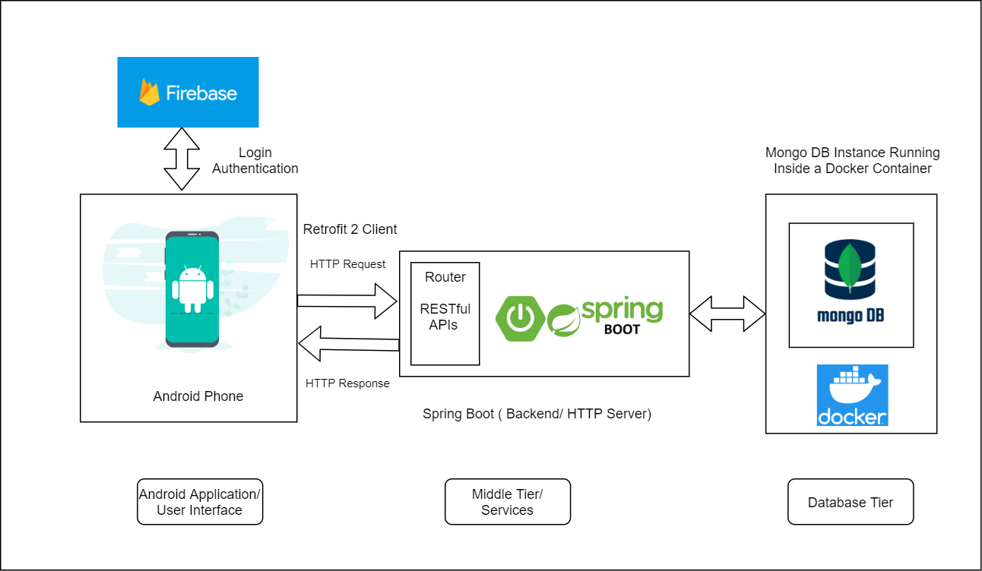

**High Level Design**

**Android App (User Interface):** Broadly speaking, the android application acts as the UI for the project. The android application is responsible for interacting with user and capturing the data, which is then passed onto the backend server using the Restful APIs using the Retrofit 2 Http Client. It is also responsible for showing the maps view and retrieved results back to user. Other than this, the application interacts with the firebase login to enhance the security of the application.

**Firebase:**  The android application uses the Google Play Services, and Firebase Login Services that capture the user’s credentials and validate it using the Firebase services. After the user is authenticated then only he can move on to interact with the rest of the application.

**Spring Boot (Middle Tier):** it provides the backend tomcat server which has REST Controllers and endpoints that listens to the incoming HTTP requests and maps them and performs the business logic and acts as a middle tier that interacts with the database layer of the project.

**Mongo DB (Database Tier):** To save the data centrally, I have used the Mongo DB database as its is easier to store the unstructured data generated by the application/ user. It is also helpful as it is dynamic and can easily adapt to changes in the design of the application. As the development is done locally, I have used a Docker platform to host the mongo dB in a containerized form.

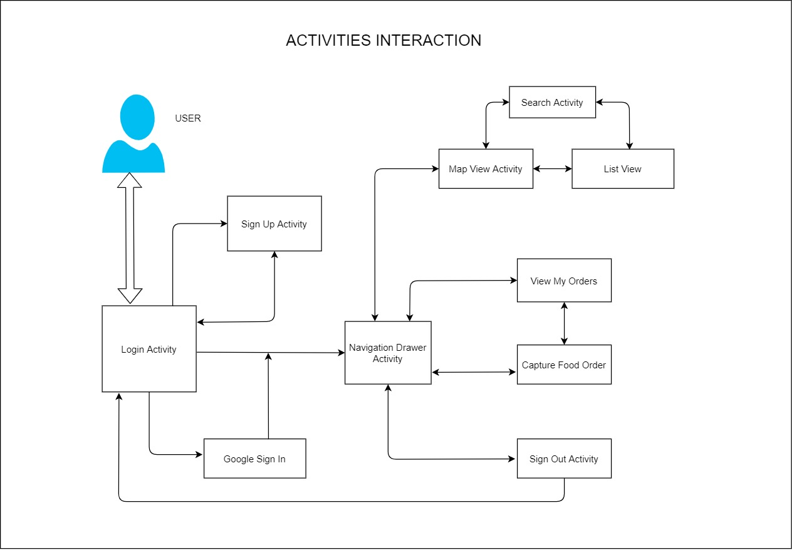

**Activities Interaction and Flow**

# Chapter 4: Results, Finding and Analysis

**Login Flow**

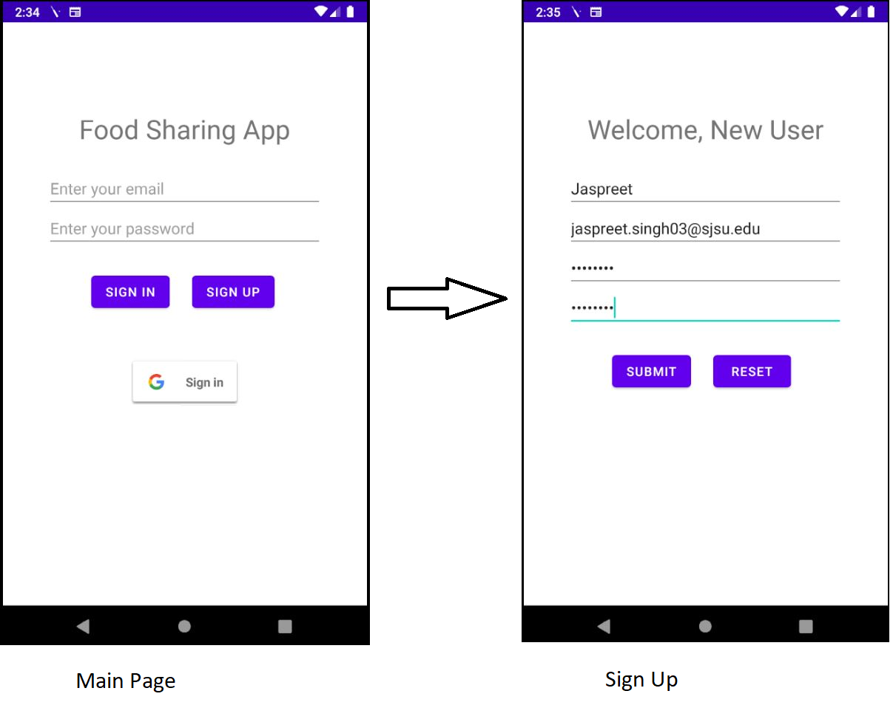

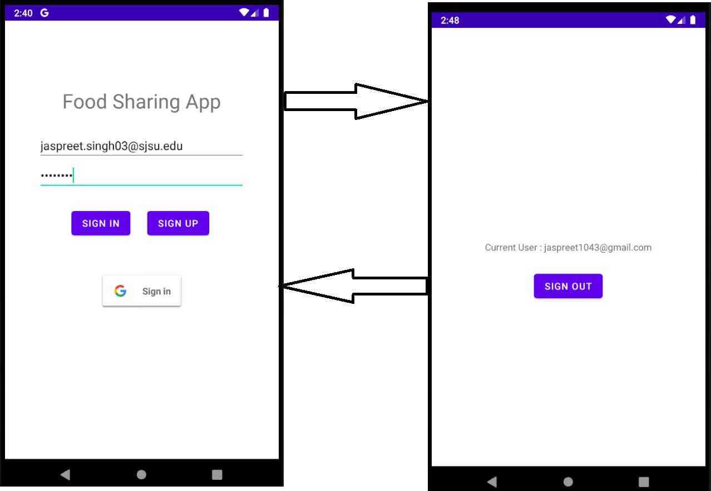

**Navigation**

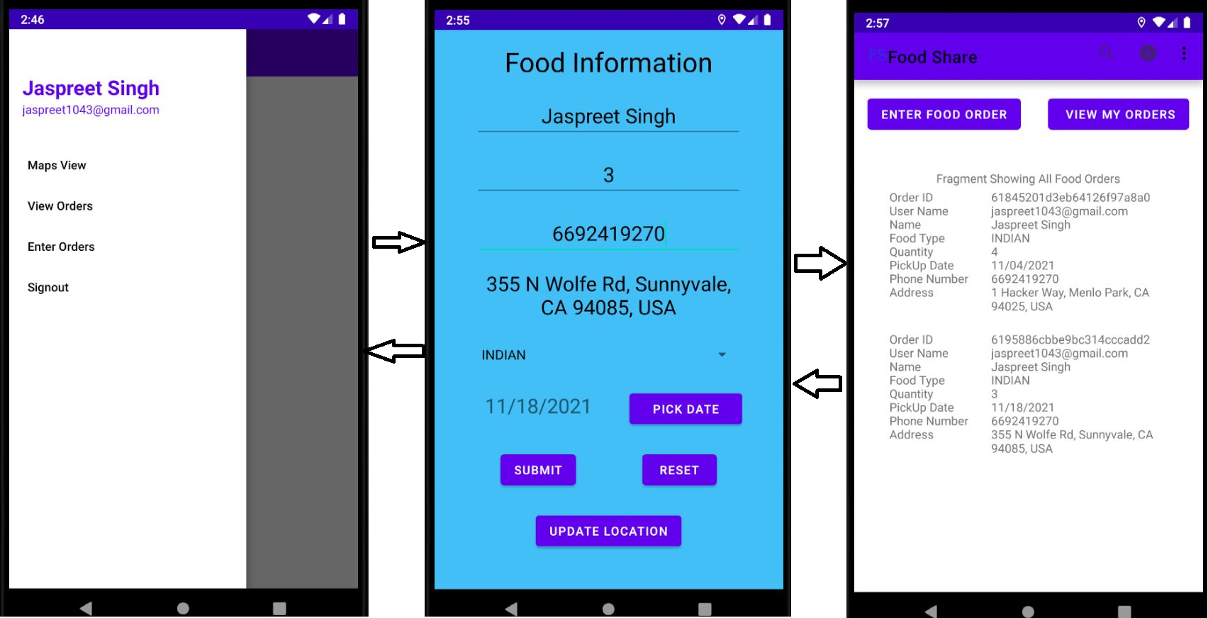

**Maps and List View**

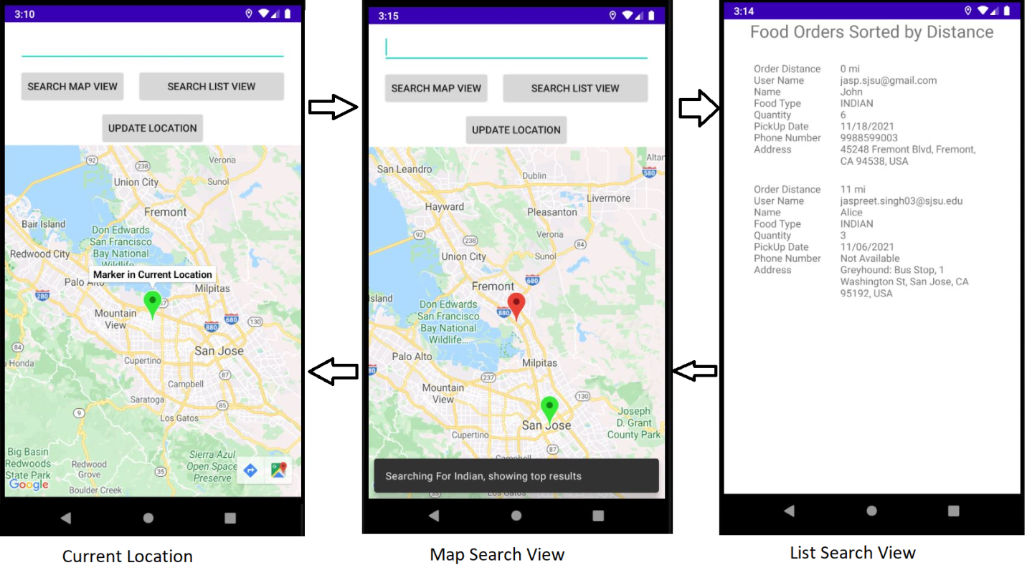

### Chapter 5: Conclusion and Recommendation

**Project Learning’s and Outcomes:**

* Activities Lifecycle, Message Passing using Intents & Manifest
* Creating Layouts and Widgets and their usage
* Designing User Interface using Material Design Theme
* Interacting With Google Maps
* Recycler View and using Fragments
* Retrofit 2 (Http Client) API usage
* Security Concepts using Google Firebase Login

**Possible Future Improvements:**

* Improving the User Interface
* Enhancing the captured details and add machine learning
* Adding Payments and Transaction so that users can also sell the food items

# References

[1] https://www.fda.gov/food/consumers/food-loss-and-waste#:~:text=In%20the%20

United%20States%2C%20food,worth%20of%20food%20in%202010

[2] https://www.rts.com/resources/guides/food-waste-america/

[3] https://ushunger.org/?gclid=CjwKCAiA7dKMBhBCEiwAO_crFEGSbnBI1AKHaRcEKujfR

Kg1UvmEwxH-7fQ77ZkGEAGgZPZKpcE9FhoCmVMQAvD_BwE

# Source Code Snippets

**Navigation Drawer Activity:**

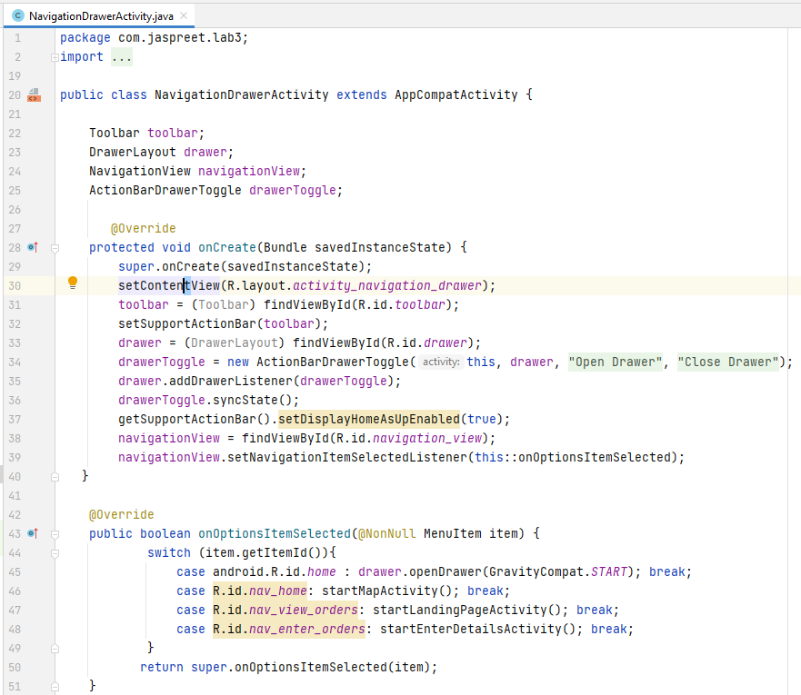

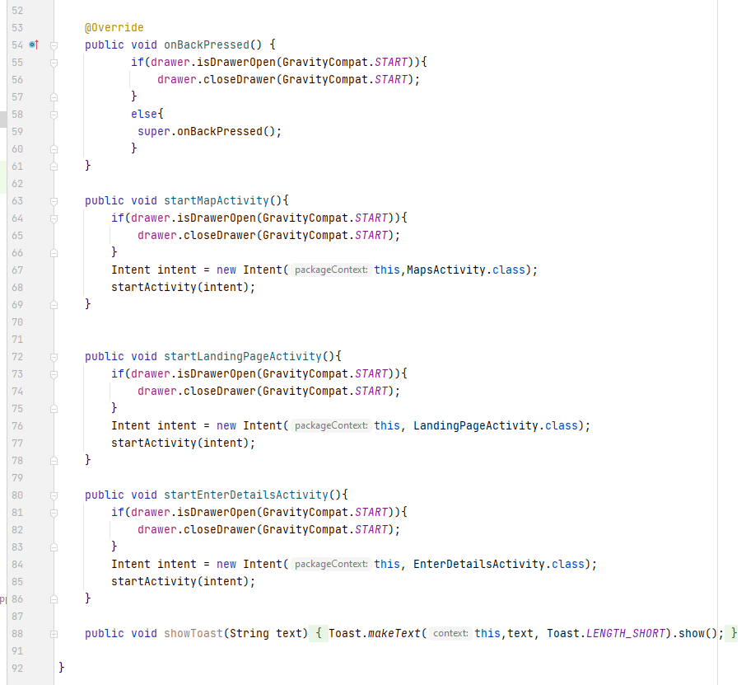

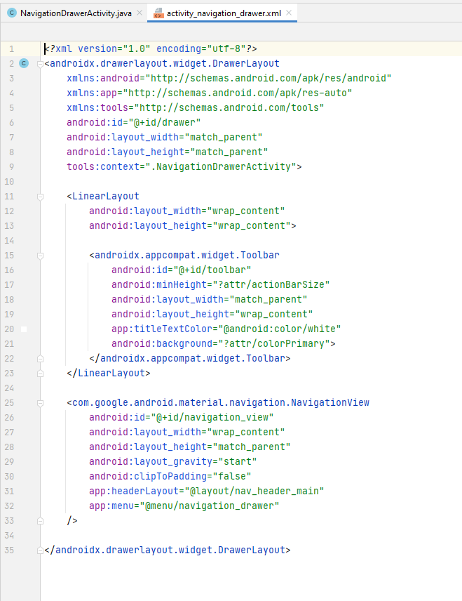

**Enter Details Activity:**

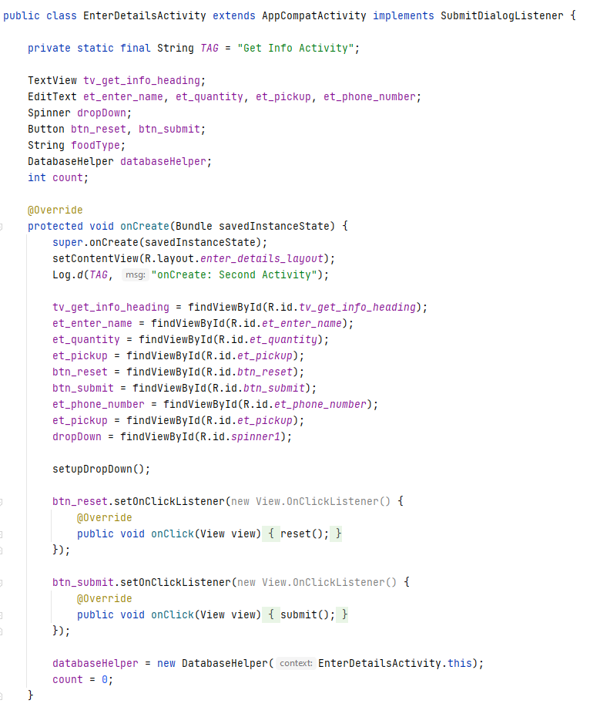

**Map View**:

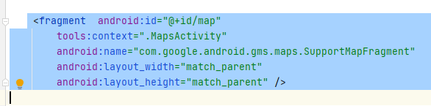

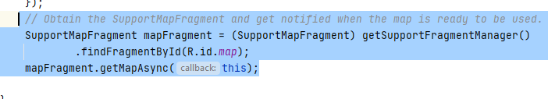

**Material Theme:**

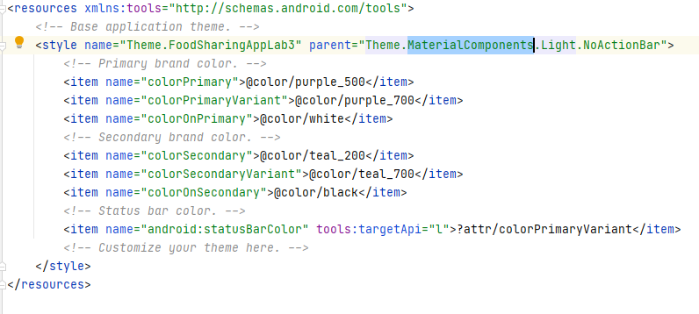

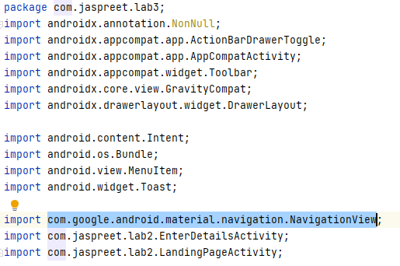



**Recycler View:**

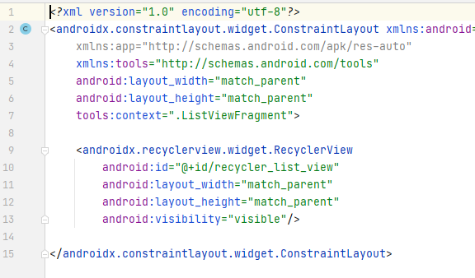

**View Holder for Recycler View:**

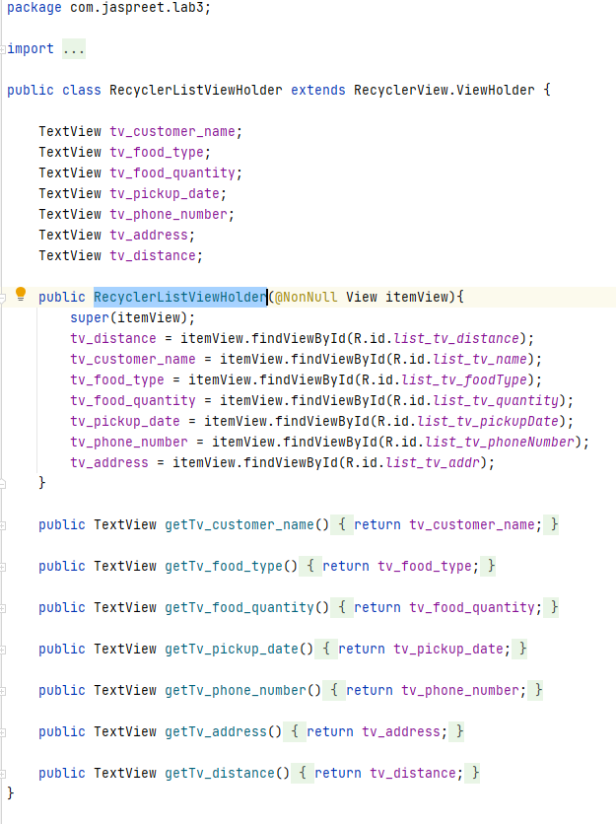

**Adapter for Recycler View:**

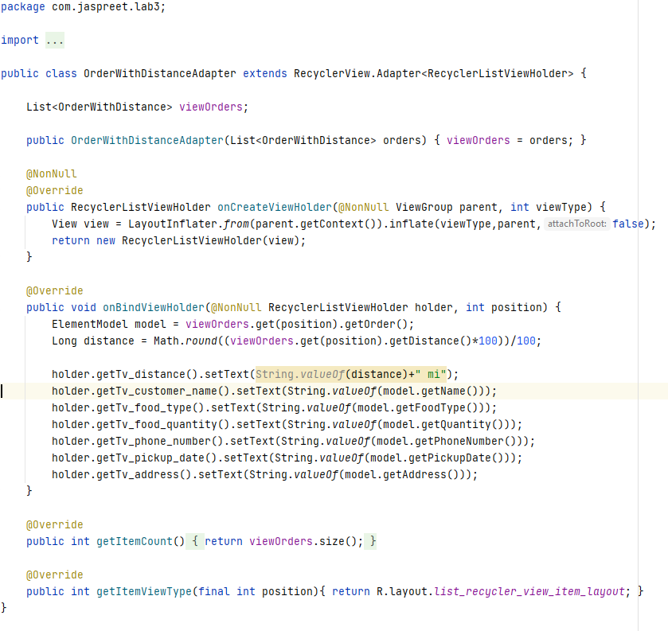

**Action Bar:**

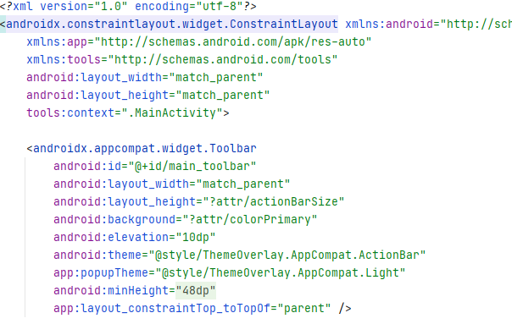

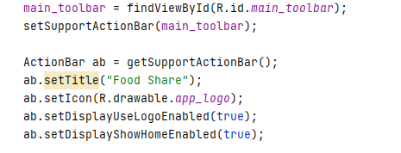

**Using Intents:**

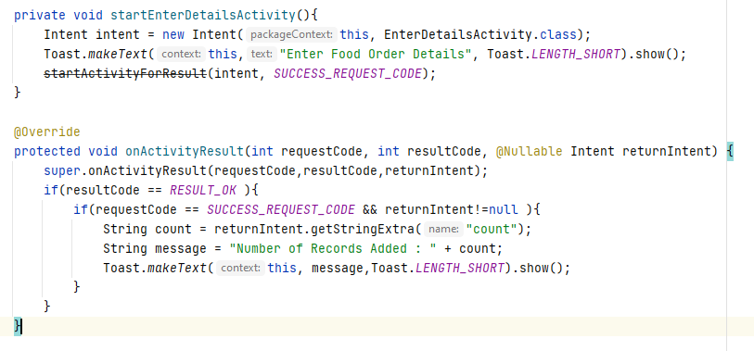

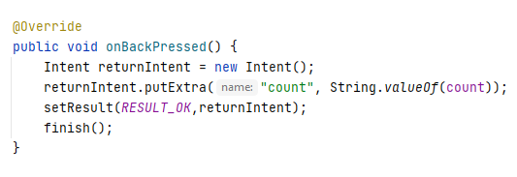

**Using Fragments:**

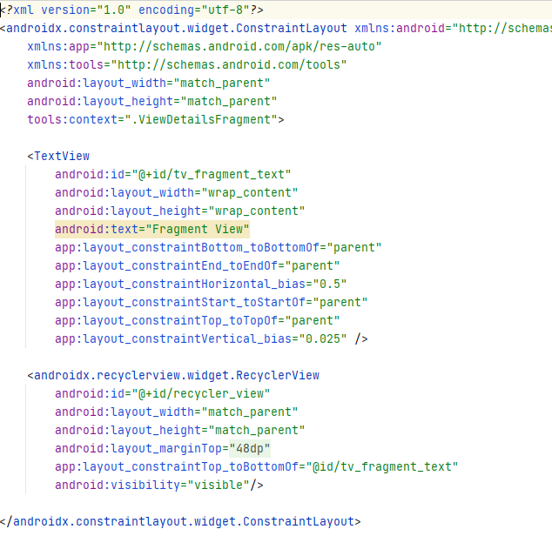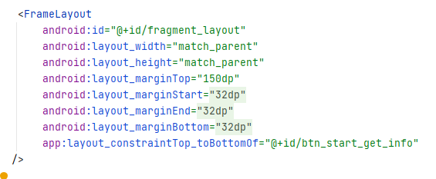

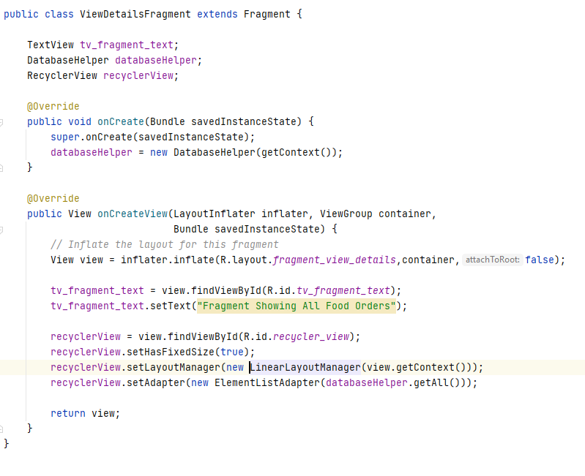

**Dialog Box:**

